Hosted by the Howard County Police Department
April 20th thru April 23rd 2026
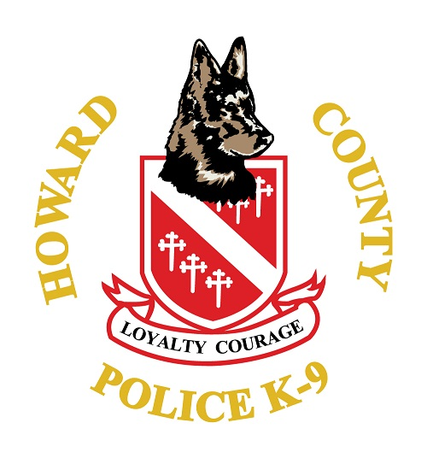
The workshop will take place at several training locations located within Howard County. The workshop will provide the opportunity to certify in obedience, aggression control, tracking, building, area searches, evidence/article search, as well as explosives and narcotics detection.
International Police Work Dog Association (IPWDA) certifications teams will have the opportunity for classroom instruction as well as problem solving, skill development and K9 First Aid based training.
IPWDA Master Trainers and Trainers from local jurisdictions will provide instruction to attending teams.

Workshop Contact Information-
K-9 Training Center- 410-313-4297
Tech Corporal Tony Camden, Howard County Police Department-
301-693-9492
IPWDA Master Trainer Brian Fleig, Anne Arundel County Police Department-
443-336-5639
Sergeant Mike Pickett, Howard County Police Department
443-340-7676

